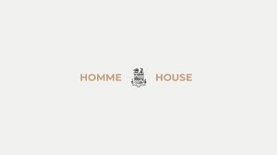
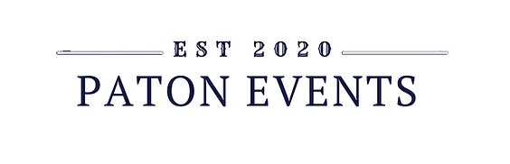
Booking Form

Please fill out this form completely and email it back to us – info@patonevents.com
No booking will be confirmed until the deposit is received.
Name:
Address:
Contact Number:
Contact Email:
Required Date:
Start Time: Finish Time:
Number of Guests: Day: Evening:
Horsebox outside or indoor bar?
Welcome Drinks?
Table Wines and/or Toast Drinks?
Cocktails?
Agreed minimum spend on the day of the event: £750 up to 99 guests. £1000 for 100 guests or more.
Any other information/requests?
Full Name:
Signature: Date:

Paton Events Terms and Conditions - Booking & Payment
- To confirm your chosen date, a signed Terms & Conditions form, a Booking Form and quoted deposit payment must be
received within 48 hours of the initial request.
- In the unlikely event of the venue and/or the event being refused an alcohol license the booking fee less any costs
incurred in the alcohol license application process will be refunded.
- In all other circumstances our acceptance of a signed Booking Form and Terms & Conditions form and receipt of full
deposit payment will constitute a legally binding contract between ‘Paton Events’ and the client(s) named on the Booking
Form.
- Any further payments due for additional services/drinks packages must be received as cleared funds not less than
28 days prior to the event.
- Full refunds (except deposit) will only be offered when events are cancelled at least 4 weeks in advance. After this
no refund, will be applicable.
- Paton Events will be the only supplier of drinks / alcohol unless pre-arrangements have been made. Anyone seen
with any drink not supplied by Paton Events will be asked to kindly refrain from consuming their own drink. If happens
again, Paton Events will inform the Client and ask them to speak to the guest. If issue still occurs, Paton Events reserves the
right to close the bar and leave the event at any time. We kindly ask any table wine, not supplied by Paton Events is
removed 30mins after the wedding breakfast has finished.
- Paton Events operates a minimum spend policy which will be outlined with the client before booking. If the agreed
min. spend is not met on the night; it is up to the client to pay the outstanding balance. £750 for up to 99 guests.
£1000 for 100 guests or over.

All our bars work under The Licensing Act 2003, and all relevant restrictions will be upheld by our staff. It is illegal
for anyone under the age of 18 to purchase, attempt to purchase or consume alcohol at the event. We would suggest that
anyone who looks or could be thought to be under the age of Twenty-Five (25) brings photographic ID/proof of age with
them or we will not be able to serve them. We will refuse to serve anyone at the event who is or appears to be excessively
drunk or uses threatening or abusive behaviour towards staff, customers or other guests. We will also refuse to serve
anyone who purchases or attempts to purchase alcohol for someone under the age of 18 or someone who has previously
been refused alcohol by the bar staff. The decision on such matters will be taken by the bar staff and will be final. The bar
staff also reserve the right to close the bar at any time if, in their opinion, unruly or troublesome behaviour has arisen or is
likely to arise within the venue or its environment.

Please also sign the T’s & C’s.

I agree to the above terms and wish to continue to book with Paton Events.

Full Name:
Signature: Date:
Paton Events
14 Springfield Road
Withington
Hereford
HR1 3RU
07967531501
patonevents@hotmail.com

BACS
Account Name: Paton Events
Bank: Royal Bank of Scotland
Acc no: 11129346
Sort Code: 16-20-38

